DAT 515 uCertify Lab Activity Worksheet

Overview
This course uses uCertify virtual labs to practice working with the techniques and tools covered in the module learning. This lab activity worksheet will assist you in organizing your work and submitting the assigned labs throughout the term. Please note that the number of labs assigned in each module may vary, so adjust your uCertify Lab Activity Worksheet accordingly. Replace all bracketed text in this worksheet with the appropriate responses.

Instructions
For each lab assigned in the module, you must:

- Save a copy of the uCertify Lab Activity Worksheet using the following naming convention, replacing the bracketed text: DAT_515_Module_[Number]_uCertifyLabActivity_[First Initial, Last Name].docx
- Follow the instructions in uCertify to complete all aspects of each lab. Be sure to follow each step carefully and thoroughly test your work.
- Take screenshots of the completed labs using the uCertify snipping tool. Ensure your name and the lab number are visible. Add the screenshots to the Lab Screenshots section below.
- Answer the lab reflection prompts provided below.
- Save and submit your completed worksheet in Brightspace to be graded by your instructor.

Module Labs
Module 3
2.2.1
2.4.1
2.5.1
2.6.1
2.6.2
2.7.1
3.10.1
3.11.1
3.12.1
3.13.1

Lab Screenshots
2.2.1
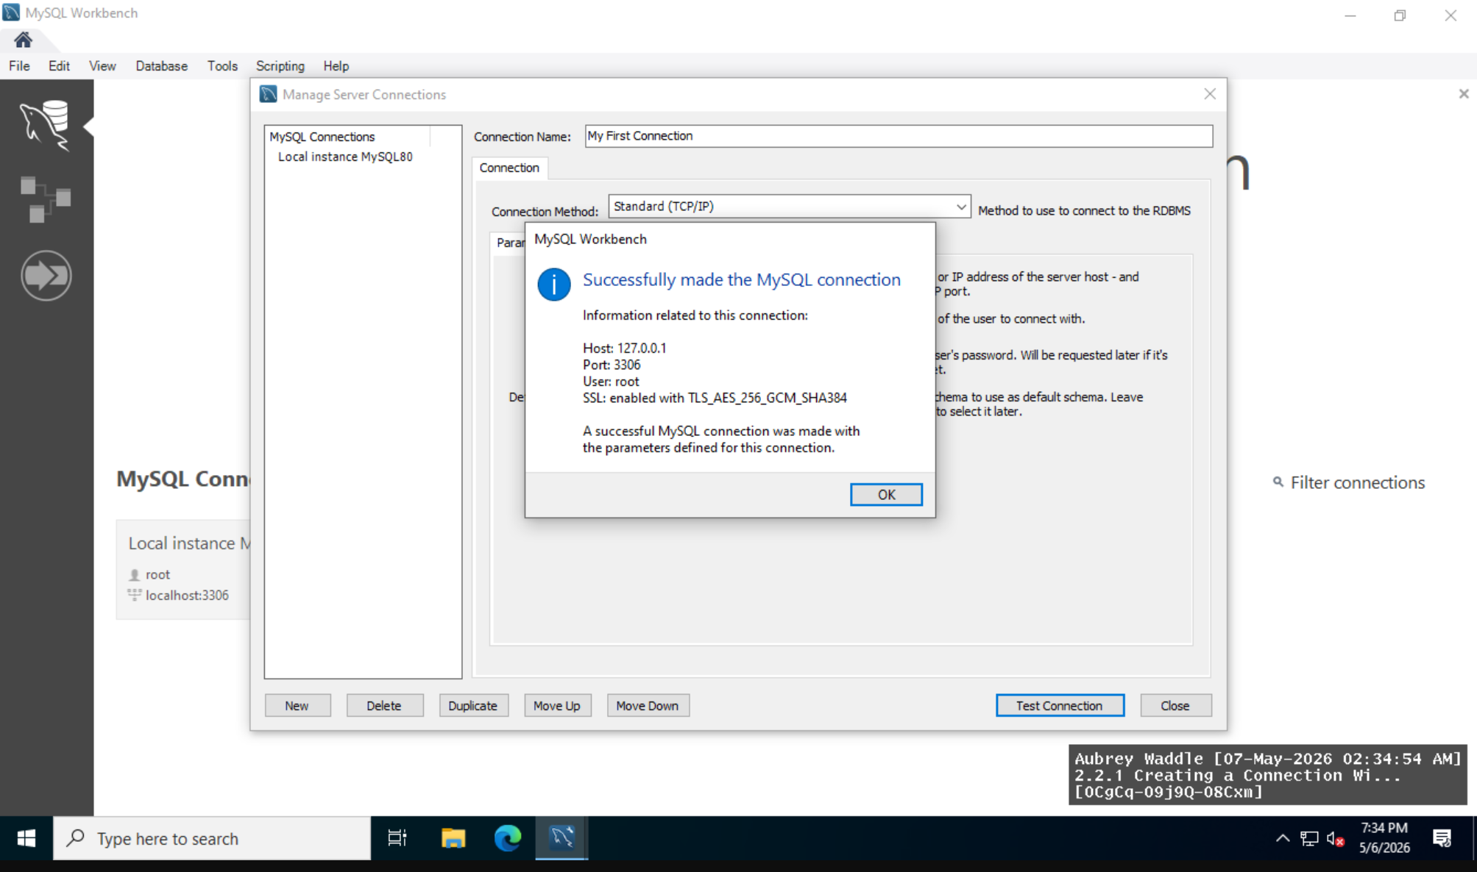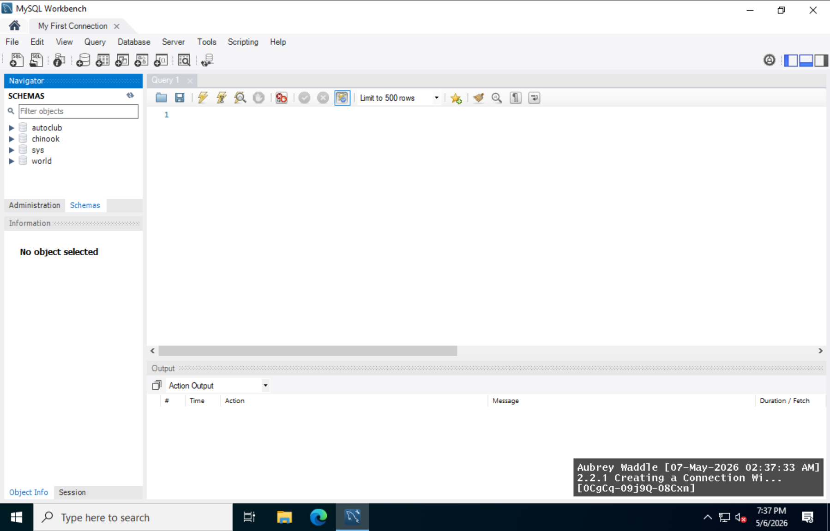
2.4.1
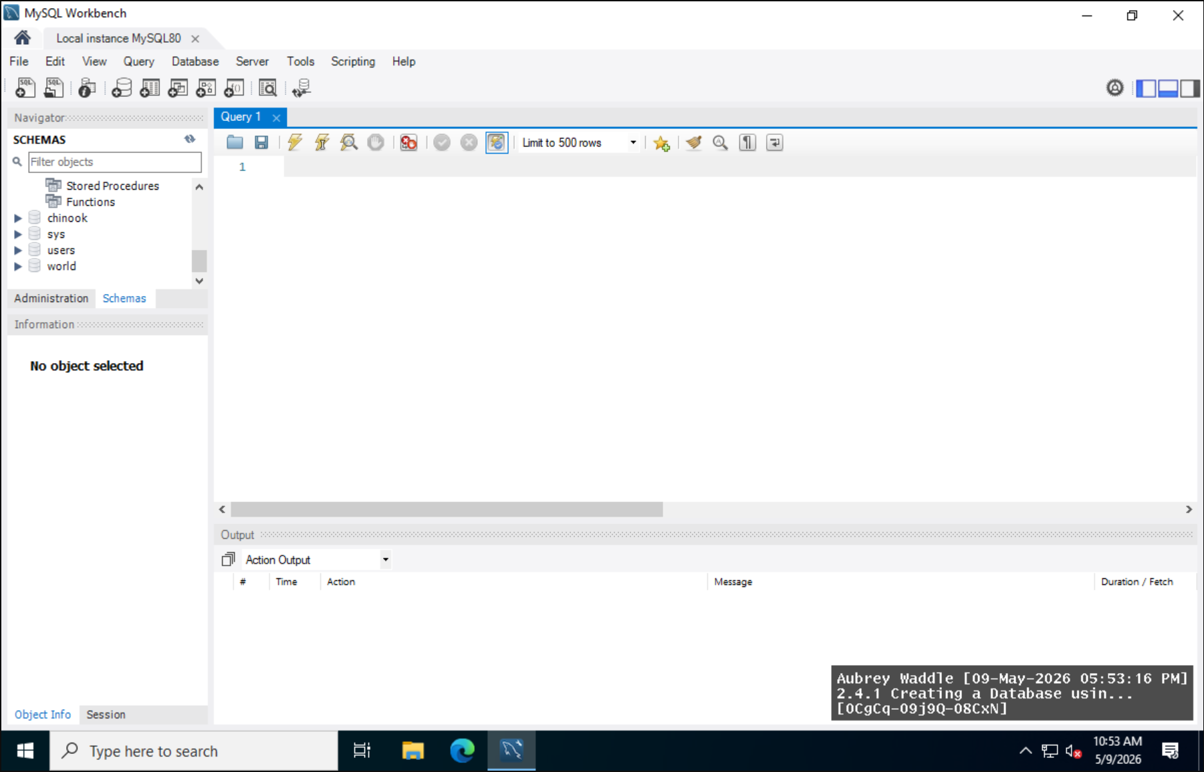
2.5.1
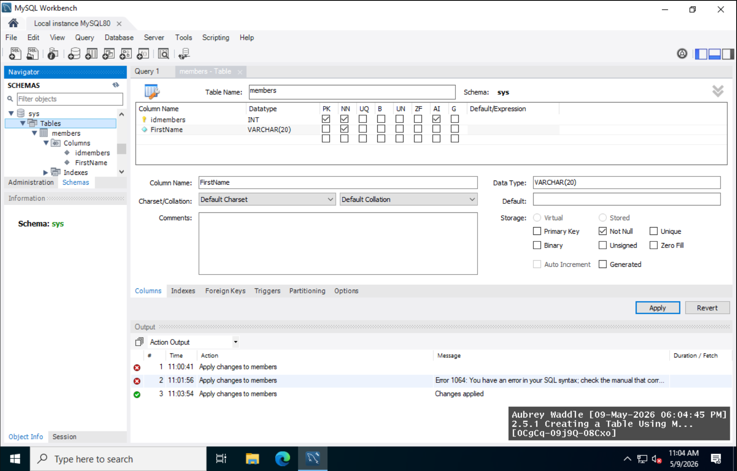
2.6.1
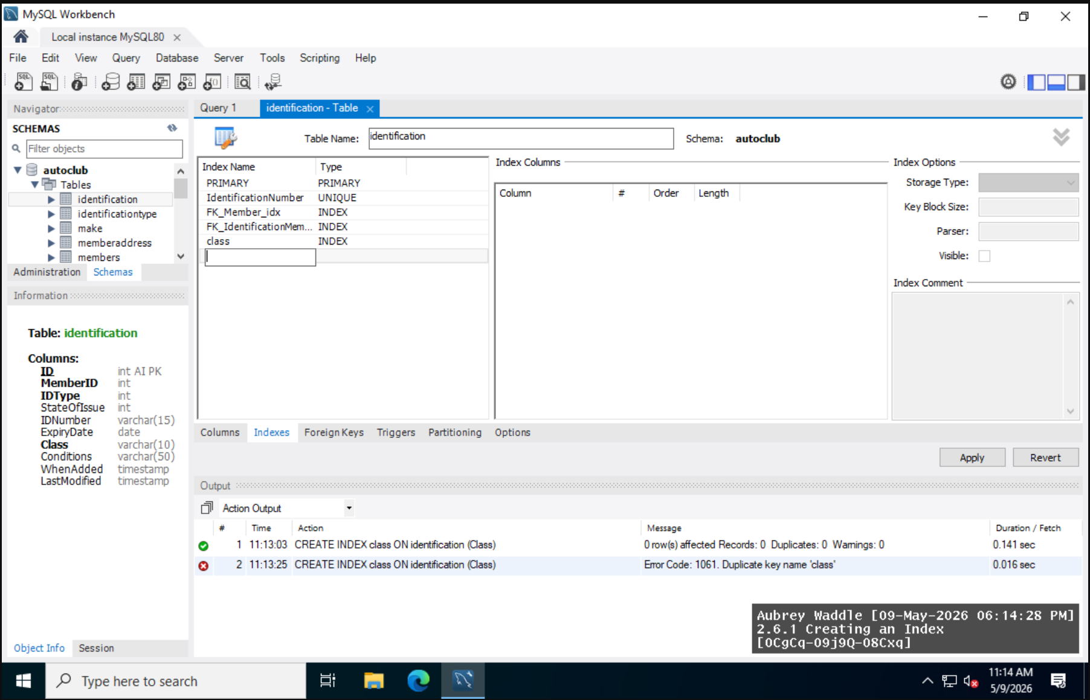
2.6.2
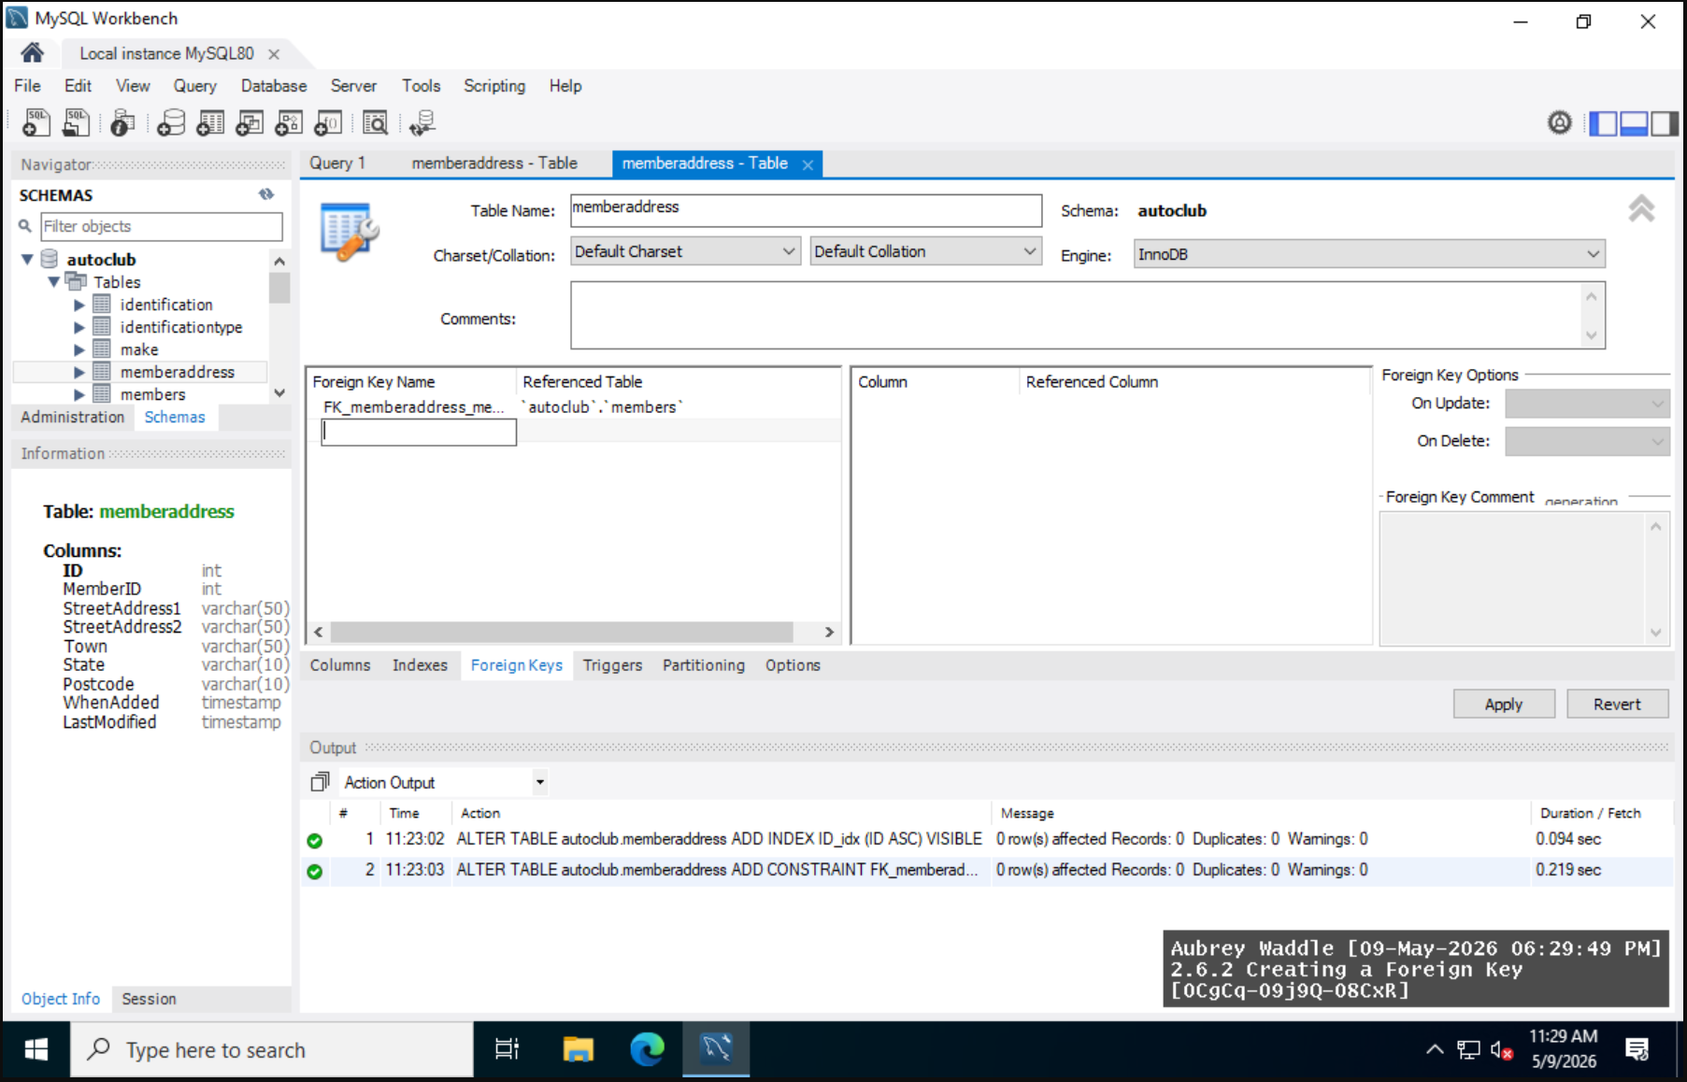
2.7.1
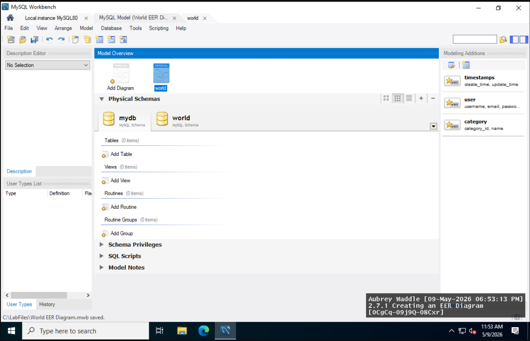
3.10.1
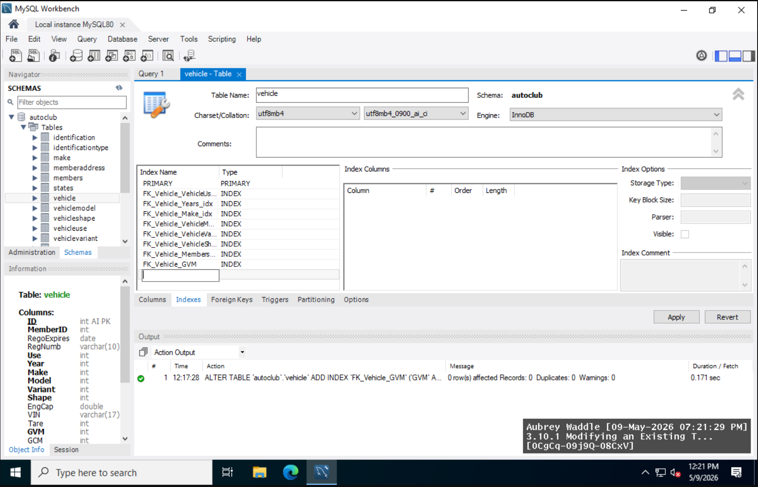
3.11.1
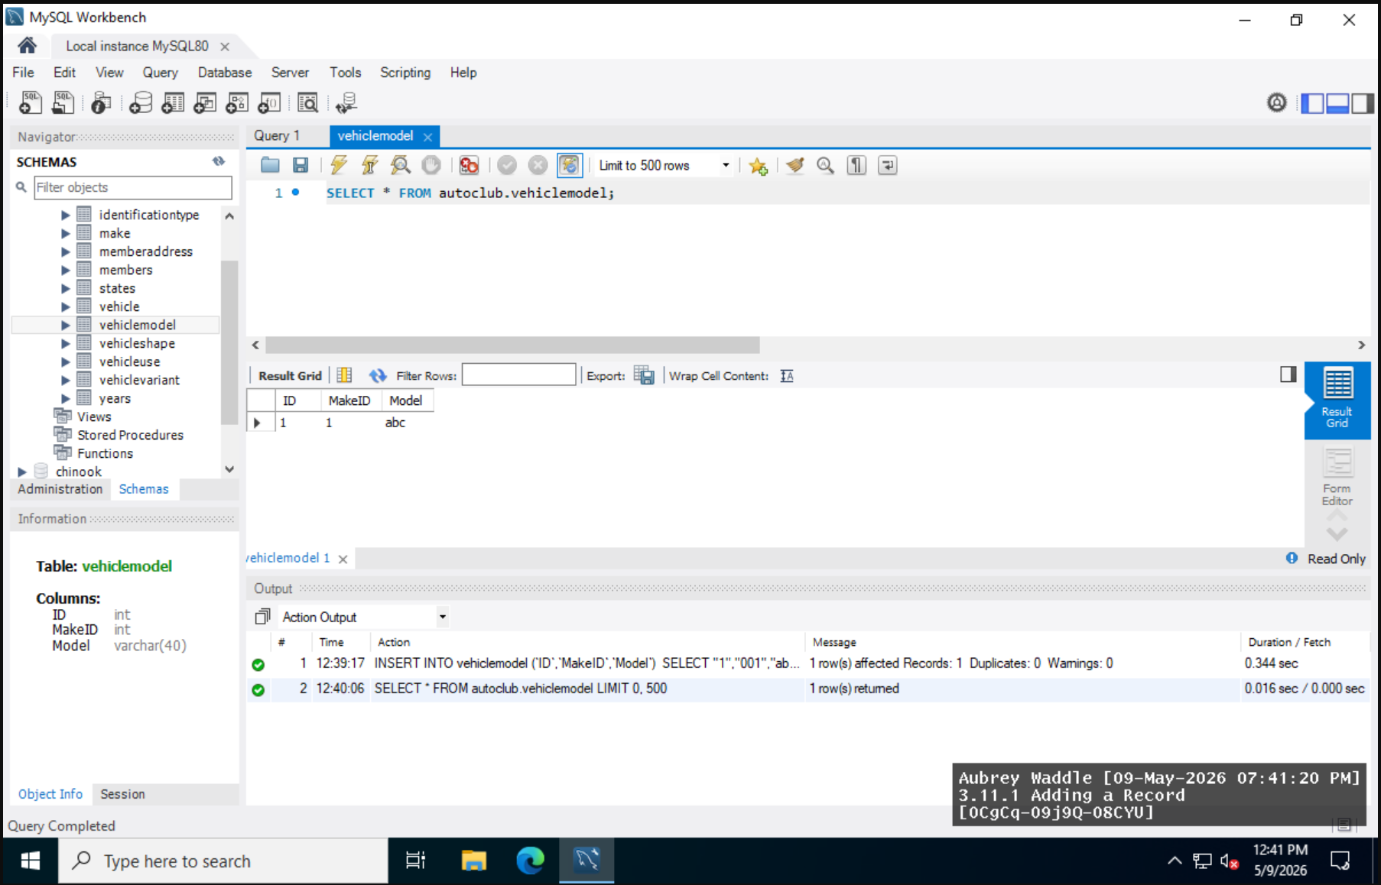
3.12.1
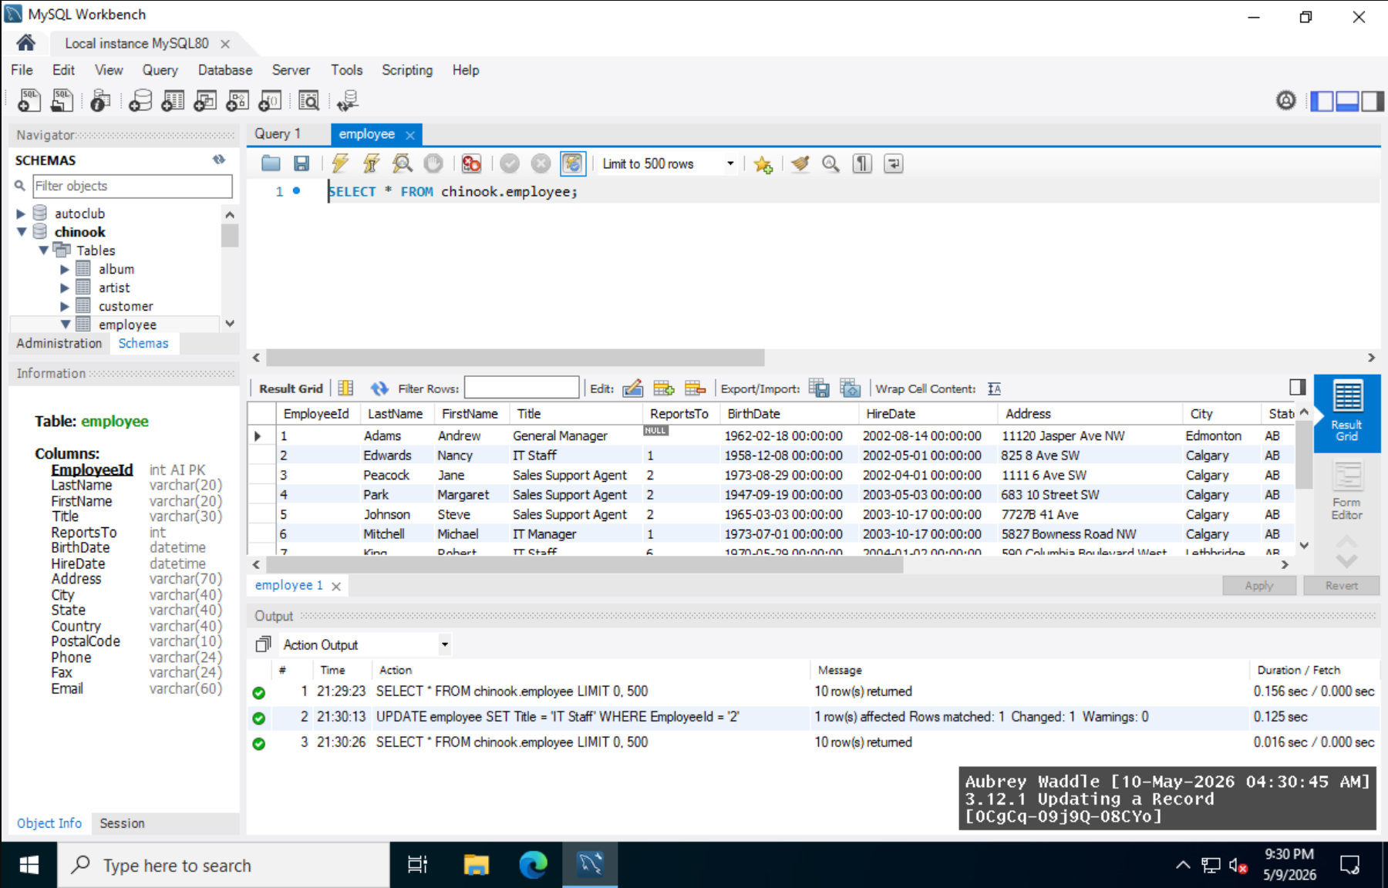
3.13.1
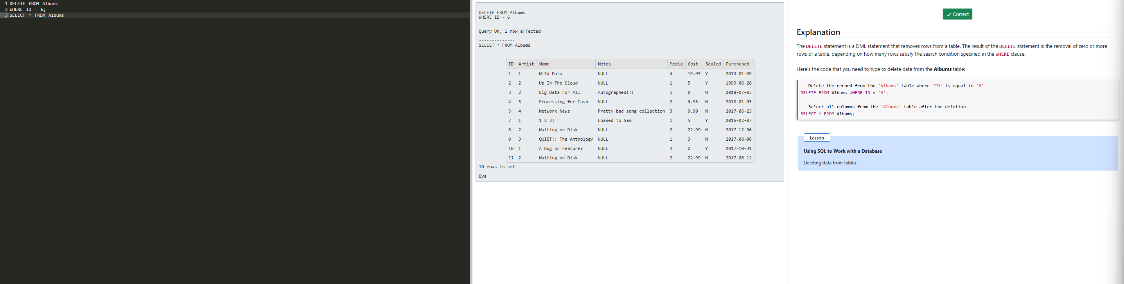
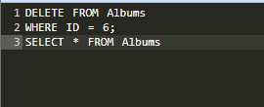

Lab Reflection
2.2.1
In this lab, I learned to create and test a link using the graphical user interface of MySQL Workbench. I checked the whole MySQL Workbench area. I attempted to set the host, port and account info of the connection.

2.4.1
In this lab I learned how to use MySQL Workbench to create a new database structure and set up character sets such as utf8mb4. This lesson was a continuation of the labs on creating a Microsoft Access database. It was about the management of schema and working with big data bases.

2.5.1
In this lab, I created tables by setting constraints, foreign keys, column names, and data types using MySQL Workbench. It depicted relational database architecture, as with the earlier normalization and relationship labs.

2.6.1
In this lab, I learned how to create indexes in MySQL Workbench by SQL queries and graphical user interface. The lab how database optimization might benefit firms with lots of data and transactional systems.

2.6.2
I used SQL ALTER TABLE statements to construct foreign keys and practice establishing associations between tables in this lab. This reaffirmed ideas from previous labs about referential integrity and relational database design.

2.7.1
In this lab I used the reverse engineering tool in MySQL workbench to create an EER diagram and looked at it. The diagram showed relationships, primary keys and foreign keys between tables which helped me understand database organisation better. This type of visualization can be used by analysts and IT teams that need to document and analyze complex relational systems such as database workers.

3.10.1
In this lab I modified a previous table by assigning an index on a field using MySQL workbench with SQL commands. This activity built on prior indexing labs to learn how to alter database structures after they have been deployed.

3.11.1
I learned how to add records to a database table using SQL INSERT INTO lines, and then use SELECT queries to test the results. This helped me remember basic CRUD operations and how to get data into relational databases.

3.12.1
In this lab I practiced using SQL UPDATE commands to update records in a database table, and using query results to verify the changes. This lab showed how to do changes to the existing data, while keeping the integrity of the structured database processes.

3.13.1
In lab I learned how to safely remove records from table by using SQL DELETE statements with WHERE clauses. I also printed the altered table to see the changed after the program is run. The lab showed the right way to store records in databases. This is to make sure that the operational systems will properly sort the data sets.

